CRIME MANAGEMENT SYSTEM.

**PROJECT BY:**

**ANKITESH GUPTA**

**ID: 141070022(14)**

**SY BTECH COMPS**

**3RD SEM**

**CRIME MANAGEMENT SYSTEM**

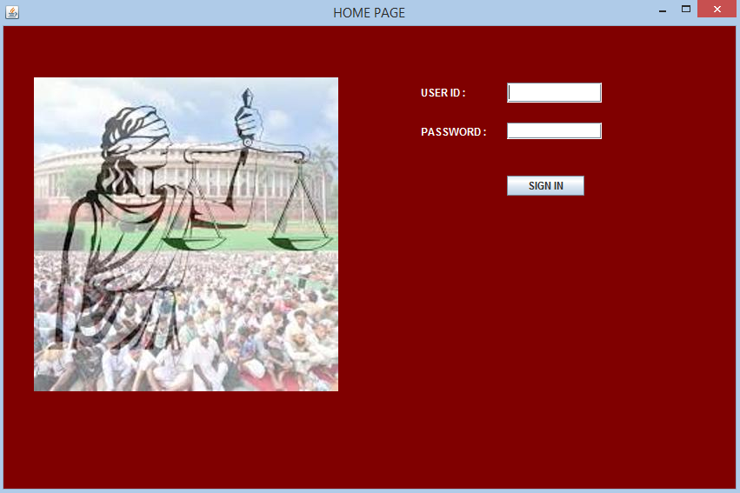

This is the login page of the system. A user can be of either a commissioner or an inspector. This is the database I’ve fed into the system.

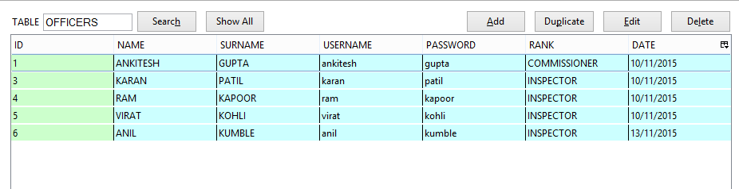

Suppose an Inspector inputs his credentials into the system. He would be taken to the following page.

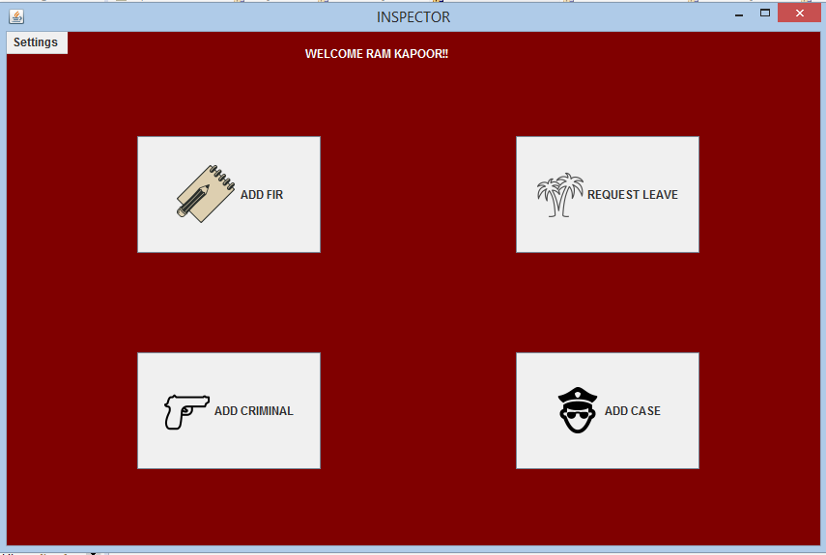

Here he can do any of the four tasks which are very essential in every police station.

1. ADD FIR
2. Request leave
3. ADD criminal : he can enter criminal Details
4. Or he can add a new case.

ADD FIR :

On clicking add fir the inspector is expected to fill these fields. 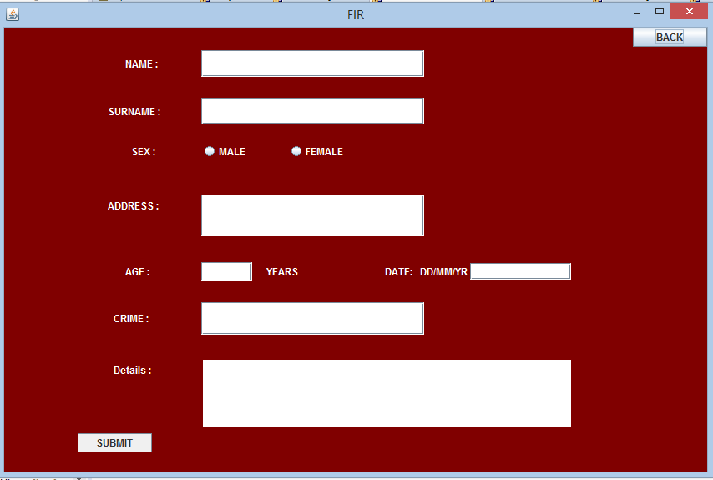

Request Leave : An inspector can also request for a paid leave.

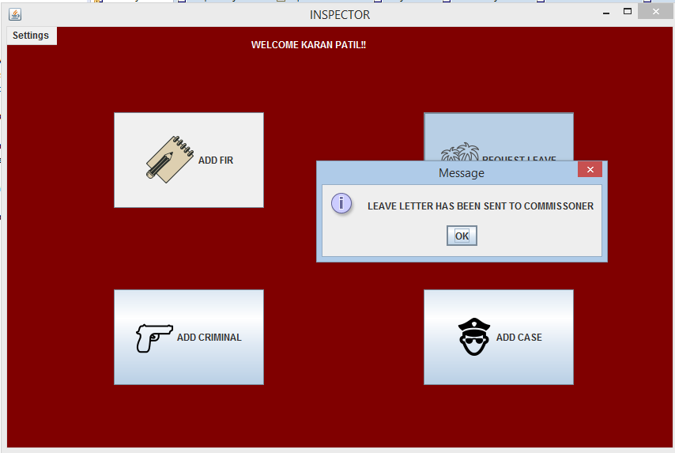

Add Criminal : The police can add an entry of a new criminal by navigating to ADD CRIMINAL

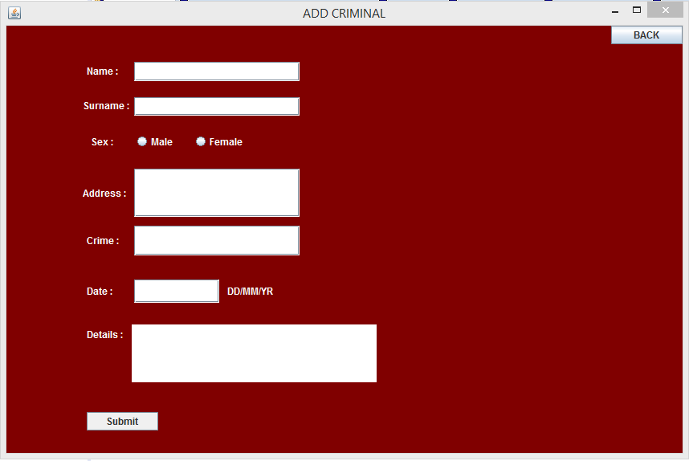

Add Case: They can also add a new case in their database by clicking add case

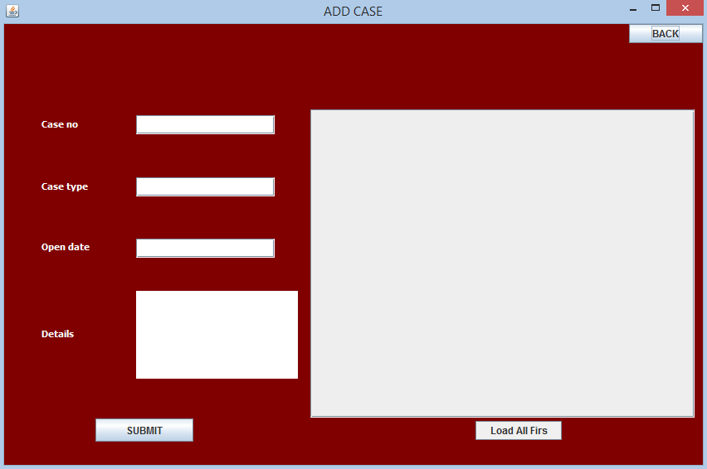

As it happens frequently at police stations that when a person registers an FIR, the FIR can be solved in many ways and even through the means of mutual settlement. When FIR isn’t solved it becomes a case. So this system facilitates the policeman to load cases from current FIR’s without referring to the main FIR file and makes it more convenient for the policeman.

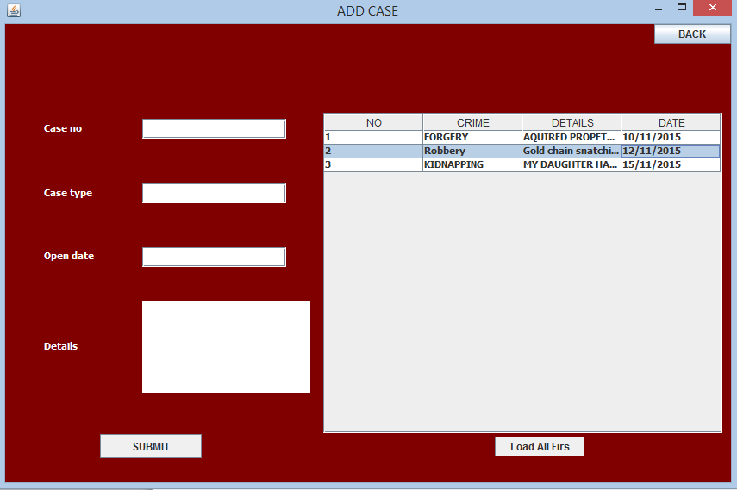

A commissioner at the police station is required to monitor all the cases at the police station. His main tasks include closing a case, to add a new police officer, to transfer an officer or to search the database for any other investigations.

When a commissioner signs in into the system he is taken to the following page.

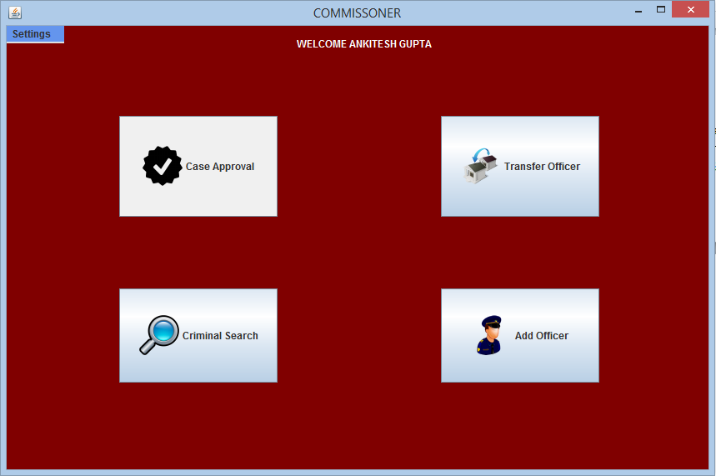

On clicking case approval:

Here he can close a case by referring to the file or by simply clicking load all cases.

After all cases are presented to him, he can see the status as C or O describing closed or open respectively.

On finding his intended case, he can enter the case number and close the case.

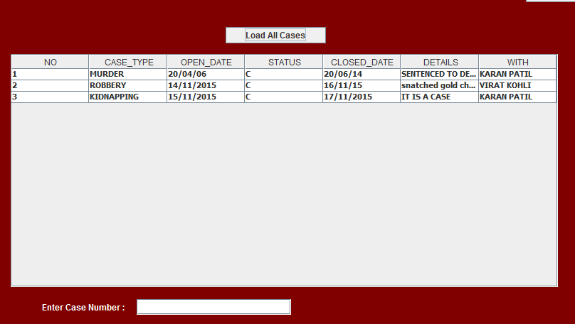

As stated earlier, the commissioner can also transfer officers in the hierarchy lower to him.

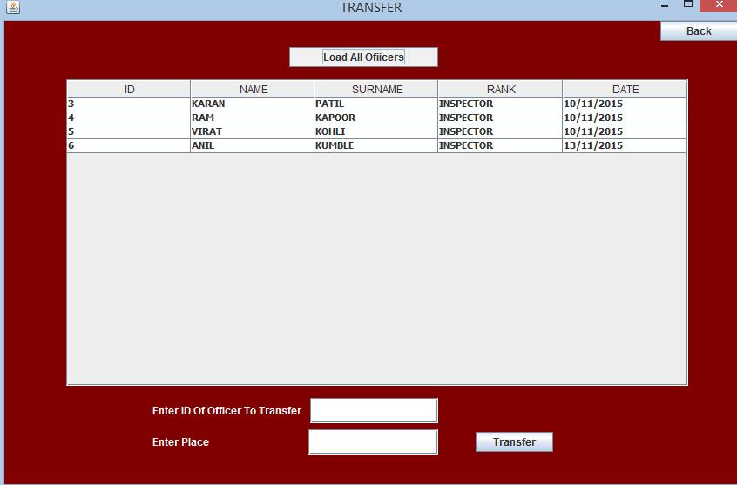

Or look for criminal records

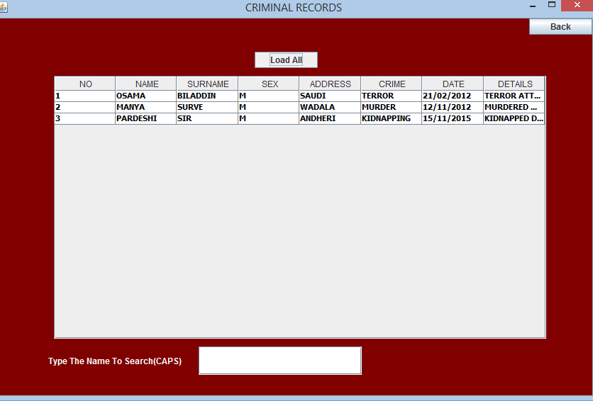

And he can also make an entry for a new hired police officer.

